The History of Wilkinsburg

A Works Progress Administration mural, is located in the Borough Building of Wilkinsburg at 605 Ross Street in the stairwell between the 2nd and 3rd floors. Originally titled “The Kingdom of Smoke”, there is a movement to use the title “The History of Wilkinsburg”. There may have been a time when the phrase “Kingdom of Smoke” connoted success and progress in industry, but the Post-Renaissance of Pittsburgh favors the aspect of history and neighborhood captured in this 1940 mural by Harold Carpenter, an artist based in Wilkinsburg. As a conservator whose goal is to preserve the history, I see a parallel between the changing of title and the removal of 80s years of soot and dirt made by “The Kingdom of Smoke” to reveal the beautiful bright palette the artist originally intended for this public space. A conservator finds it interesting that 80s years of collected soot and dirt could be safely removed within 4 weeks of diligent care.
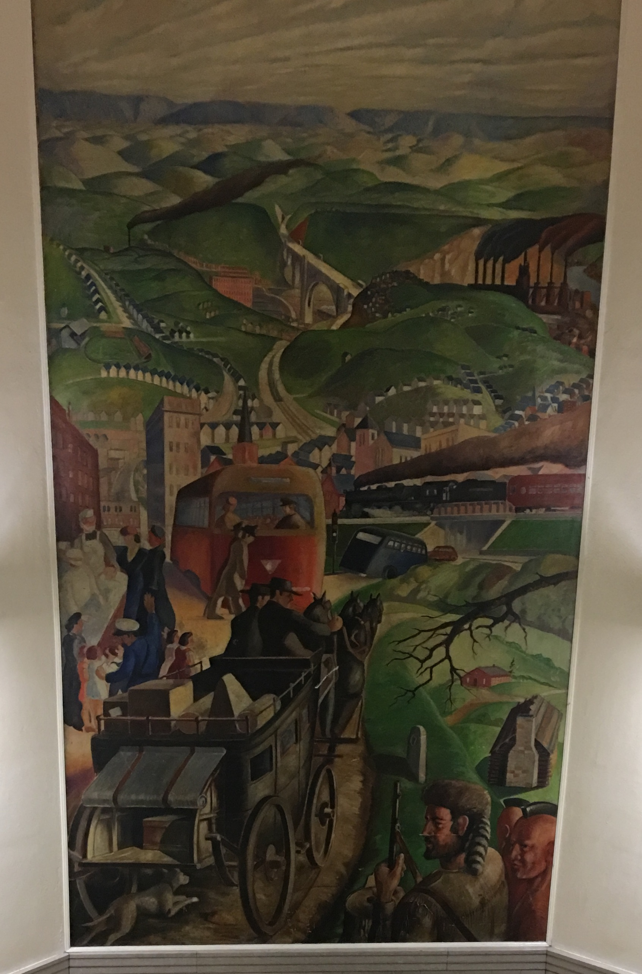
Before Treatment

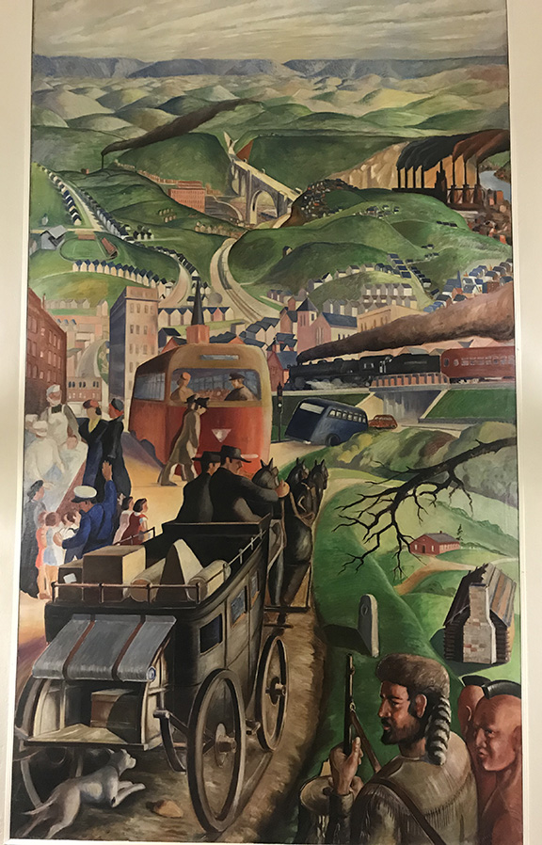
After Treatment

The lower portion of the mural depicts early history of the borough as represented by First Nations men and a trapper in the bottom right and a stagecoach with travelers and belongings in the bottom left. Progress is represented by the medical team at the left edge and new forms of transportation in the middle ground. The Westinghouse Memorial Bridge and industrial plants in Rankin and Braddock are depicted in the background.

The “History of Wilkinsburg” was carried out in oil on canvas, probably in the studio of Mr. Carpenter and was installed by a technique known as marouflage whereby the canvas is permanently affixed to a wall with adhesive, a common technique in the WPA mural program between 1934 and 1943. In fact, small tack holes are visible along the top edge of the mural, which indicates that the canvas was once secured to a wooden stretcher. A thin painted frame around the perimeter covers tack holes around the lower and vertical edges.

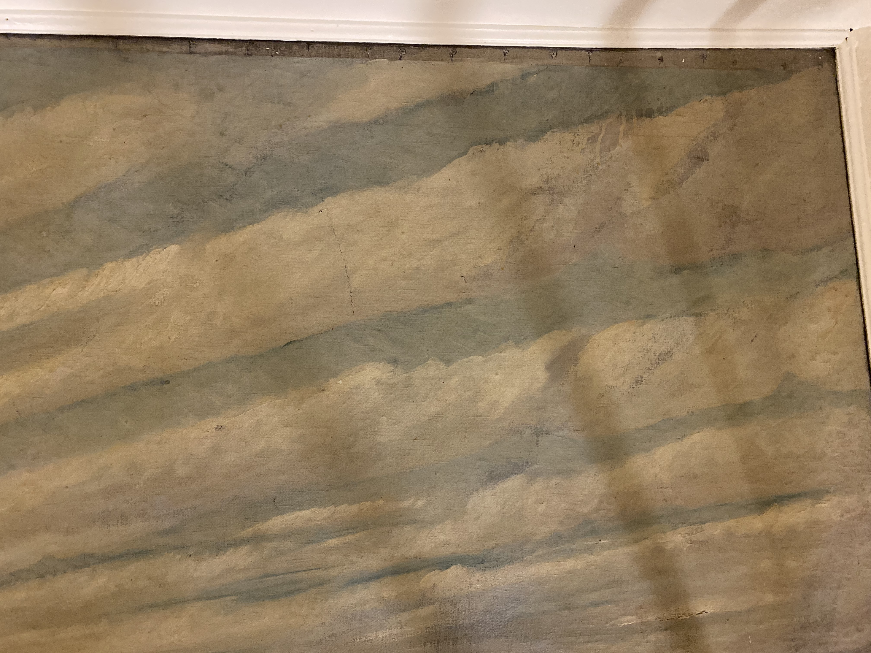Detail of top edge where old tacking holes are visible. This image is taken before treatment (with shadows from the scaffold cast on the right side).

The artist prepared the canvas with a gesso layer, which serves to smoothen texture of the support, reduce absorption of the medium in the canvas, and provide a bright surface for the composition. The artist then carried out a preliminary sketch in a wet medium. Techniques in oil paint of wet-into-wet and wet-over-dry indicate that Carpenter painted the landscape in multiple sessions and in multiple layers. We can see the artist’s working technique in pentimenti or “regrets”. These pentimenti are changes the artist made in the composition as he was painting. He changed his mind and adjusted the position of elements in the landscape. Below, you can see the pentimento the artist made in the position of a smoke stack in the top left corner of the mural. The artist originally placed the smoke stack a few inches to the right of where it is visible today. The pentimenti are easier to see after conservation since heavy dirt was obscuring details in the mural.

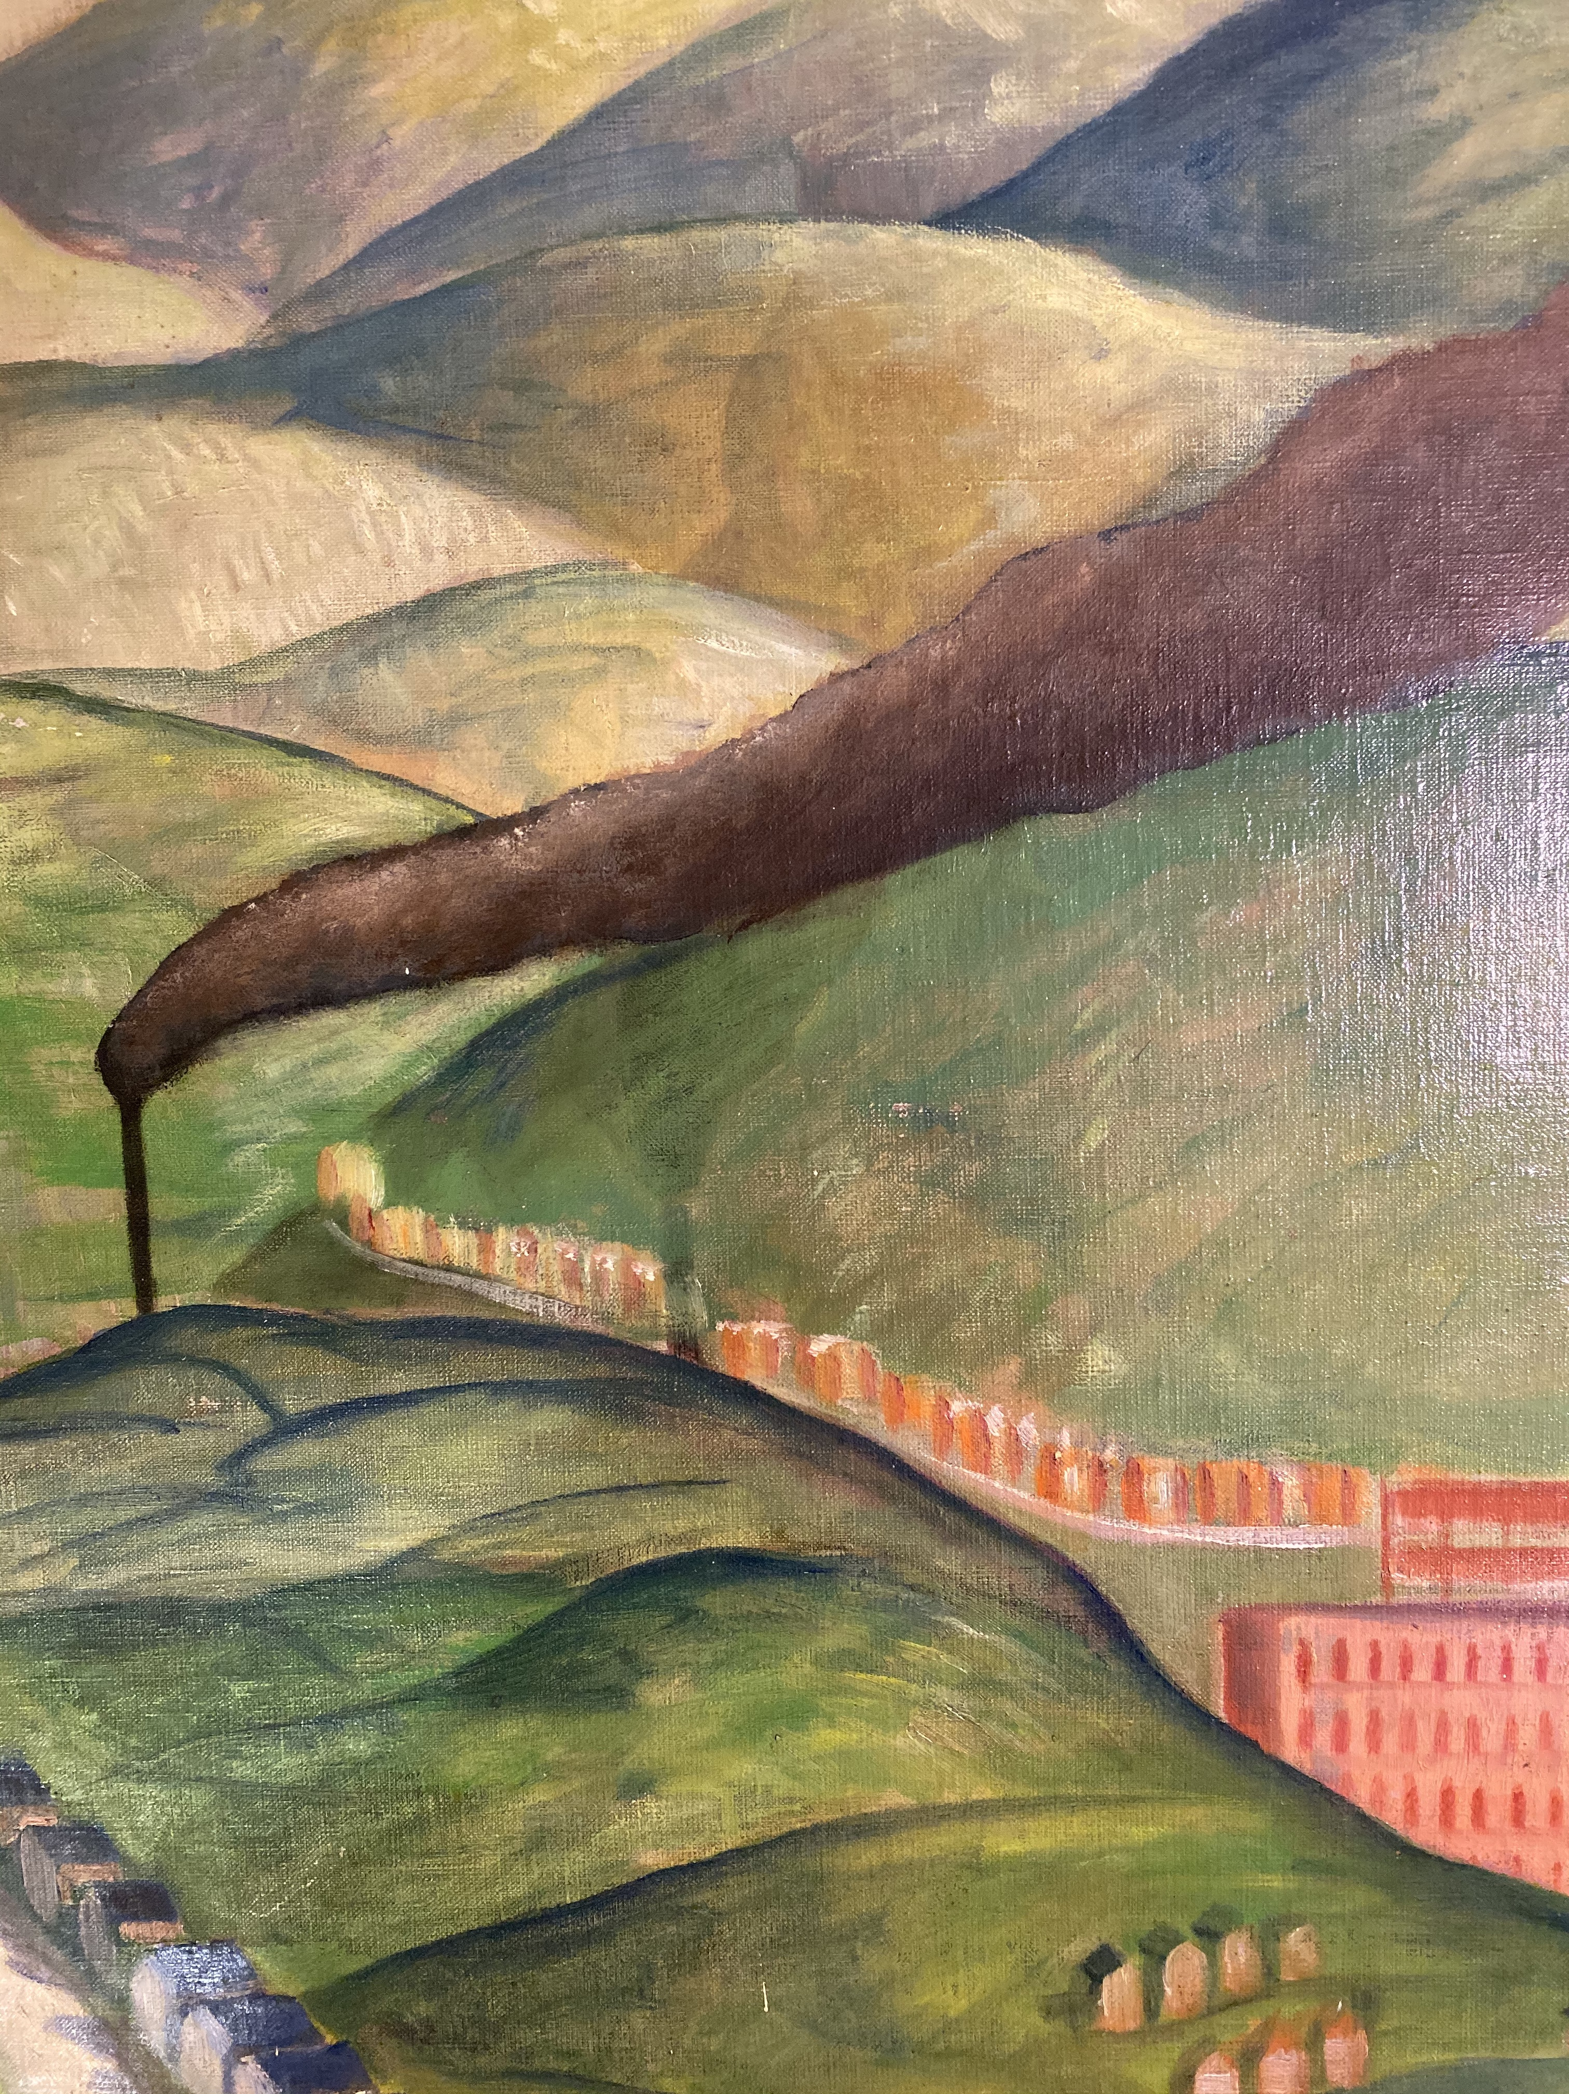
The original placement of the smoke stack was further right, as seen by the dark shadow.

Conservation measures for the mural included stabilization of small losses, removal of the 80 years of dirt with an aqueous (water-based) cleaning system, removal of graffiti, as well as filling and retouching of losses.

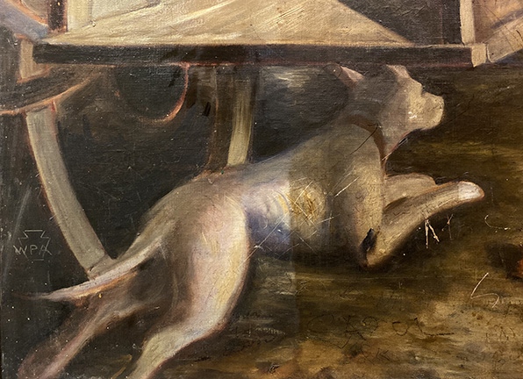
Detail in lower left during cleaning of a dog. Surface dirt is removed from the left half of the dog and remains on the right half. Scratches and graffiti are still in need of retouching.

Having spent several weeks becoming more familiar with imagery in the mural during the COVID 19 pandemic, there are a couple issues that stand out for me. Firstly, this work was painted by Harold Carpenter, a Works Progress Administration artist. The WPA was a federal agency of the New Deal, a program designed to assist artists, musicians and millions of other job seekers following the Great Depression. In other words, I, a conservator experiencing a similar, financially devastating period in American history was confronting the beautiful results of my kindred artist predecessor, Harold Carpenter. These WPA murals are a wonderfully positive outcome of challenging moments in our communities and they visually captured history in ways that may have otherwise not been documented as thoroughly.

Secondly, as I followed protocols to keep the public safe during this pandemic, such as masking up, taking and recording my temperature, working in isolation, and sanitizing hands as frequently as possible, I found myself being thankful for the small staff of medical professionals at the left edge in the middle ground who were donning masks caring for the community. It seems my fellow artist of 80 years prior was as thankful for first responders as much as I was.
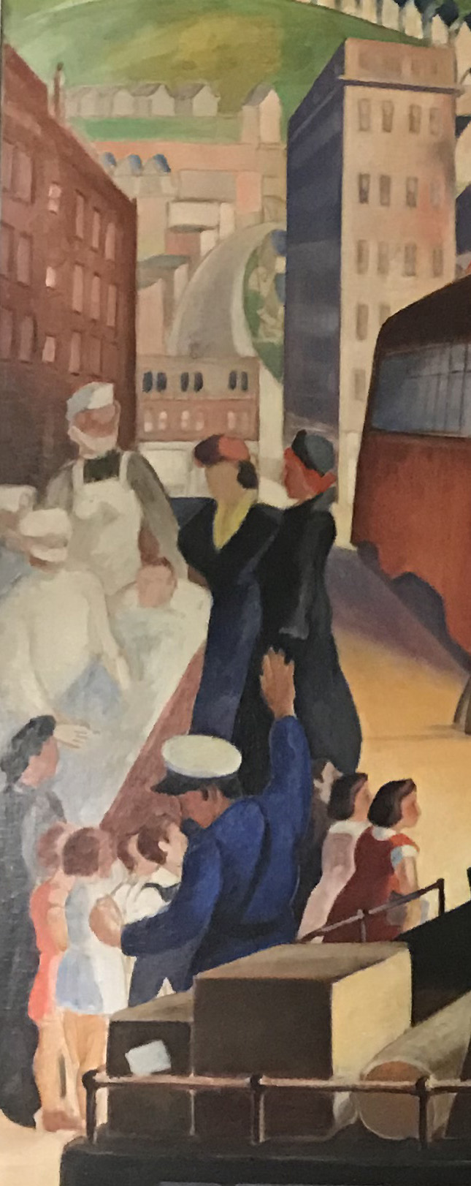Detail of medical professionals at left edge.
I would like to express my gratitutde to Jody Guy and the Civic Arts Council for the opportunity to work with them and the important WPA mural; John Antinori, the Borough Manager of Wilkinsburg for his support and enthusiasm in this Historic Wilkinsburg Project; the Institute of Museum and Library Services for the Saving America’s Treasures Project Grant; and the numerous individuals of Wilkinsburg I met in the Borough Council, Department of Public Works, (Thank you Kevin for your help!), Borough Manager’s office (Thank you Moses and Amanda for your assistance!), as well as the local branch of the Carnegie Library.

-Rikke Foulke

